Instruction TP noté relative au tp4 : 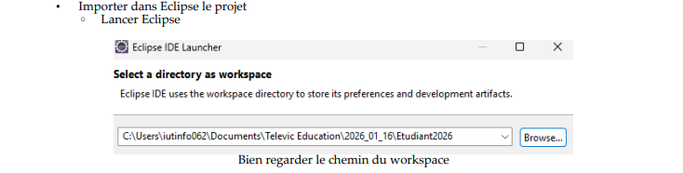

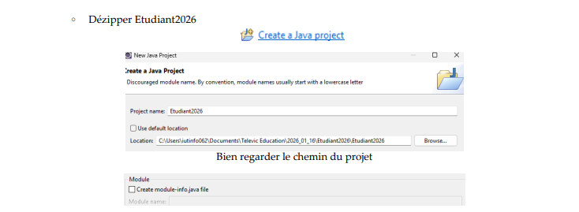

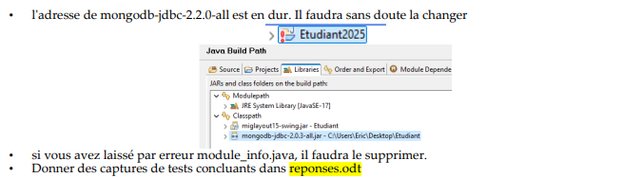

TP4 SQL :

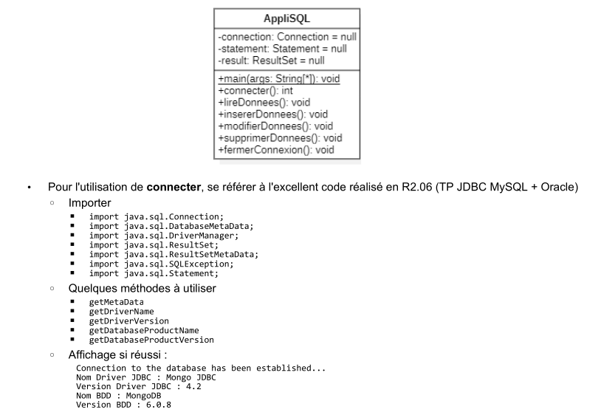

private Connection conn;

public void connecter() {
try {
Class.forName("mongodb.jdbc.MongoDriver");
} catch (Exception e) {
System.out.println("erreur driver");
e.printStackTrace();
}
try {
//String url = "jdbc:mongo://127.0.0.1:27017/maBDDTP4";
String url = "jdbc:mongo://127.0.0.1:27017/maBDDTP4?rebouildschema=true"; //afin qu'il se mette à jour automatiquement
conn = DriverManager.getConnection(url,"","");

System.out.println("Connection to the database has been established...");

DatabaseMetaData meta = conn.getMetaData();
System.out.println("Nom Driver JDBC : " + meta.getDriverName());
System.out.println("Version Driver JDBC : " + meta.getDriverVersion());
System.out.println("Nom BDD : " + meta.getDatabaseProductName());
System.out.println("Version BDD : " + meta.getDatabaseProductVersion());

} catch (Exception e) {
e.printStackTrace();
}
}
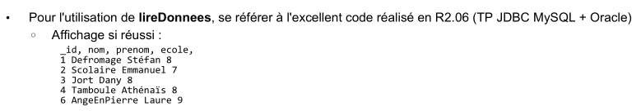

public void lireDonnees() {
try (Statement stmt = conn.createStatement()) {
ResultSet rs = stmt.executeQuery("SELECT * FROM mesprofs");

ResultSetMetaData meta = rs.getMetaData();
int columnCount = meta.getColumnCount();

for (int i = 1; i <= columnCount; i++) {
System.out.print(meta.getColumnName(i));
if (i < columnCount) System.out.print(", ");
}
System.out.println();

while (rs.next()) {
for (int i = 1; i <= columnCount; i++) {
System.out.print(rs.getString(i));
if (i < columnCount) System.out.print(", ");
}
System.out.println();
}
} catch (SQLException e) {
e.printStackTrace();
}
}

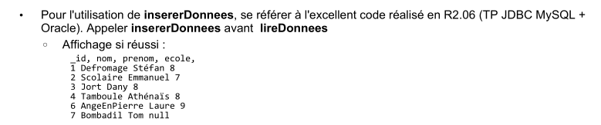

//attention on ne peux pas executer deux fois car on a mis un id en brut dans le code
public void insererDonnees() {
try (Statement stmt = conn.createStatement()) {
stmt.executeUpdate("INSERT INTO mesprofs (_id, nom, prenom, ecole) VALUES (1, 'Defromage', 'Stéfan', 8)");
stmt.executeUpdate("INSERT INTO mesprofs (_id, nom, prenom, ecole) VALUES (2, 'Scolaire', 'Emmanuel', 7)");
stmt.executeUpdate("INSERT INTO mesprofs (_id, nom, prenom, ecole) VALUES (3, 'Jort', 'Dany', 8)");
stmt.executeUpdate("INSERT INTO mesprofs (_id, nom, prenom, ecole) VALUES (4, 'Tamboule', 'Athénaïs', 8)");
stmt.executeUpdate("INSERT INTO mesprofs (_id, nom, prenom, ecole) VALUES (6, 'AngeEnPierre', 'Laure', 9)");
stmt.executeUpdate("INSERT INTO mesprofs (_id, nom, prenom) VALUES (7, 'Bombadil', 'Tom')");

System.out.println("Données insérées !");
lireDonnees();
} catch (SQLException e) {
e.printStackTrace();
}
}
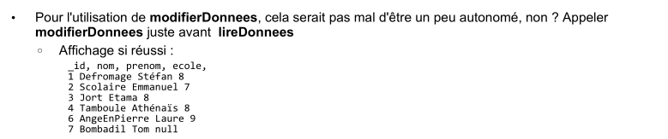

public void modifierDonnees() {
try (Statement stmt = conn.createStatement()) {
stmt.executeUpdate("UPDATE mesprofs SET prenom = 'Etama' WHERE _id = 3");
System.out.println("Données modifiées !");
lireDonnees();
} catch (SQLException e) {
e.printStackTrace();
}
}

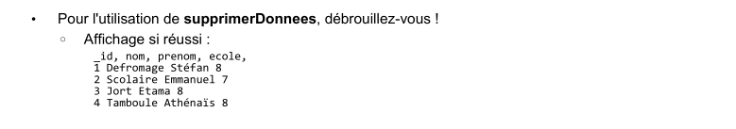

public void supprimerDonnees() {
try (Statement stmt = conn.createStatement()) {
stmt.executeUpdate("DELETE FROM mesprofs WHERE _id = 6");
stmt.executeUpdate("DELETE FROM mesprofs WHERE _id = 7");
System.out.println("Données supprimées !");
lireDonnees();
} catch (SQLException e) {
e.printStackTrace();
}
}
public void fermerConnexion() {
try {
if (conn != null && !conn.isClosed()) {
conn.close();
System.out.println("Connexion fermée !");
}
} catch (SQLException e) {
e.printStackTrace();
}
}
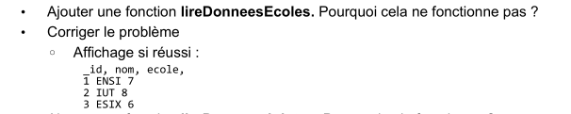

public void lireDonneesEcoles() {
try (Statement stmt = conn.createStatement()) {
ResultSet rs = stmt.executeQuery("SELECT * FROM mesecoles");

ResultSetMetaData meta = rs.getMetaData();
int columnCount = meta.getColumnCount();

for (int i = 1; i <= columnCount; i++) {
System.out.print(meta.getColumnName(i));
if (i < columnCount) System.out.print(", ");
}
System.out.println();

while (rs.next()) {
for (int i = 1; i <= columnCount; i++) {
System.out.print(rs.getString(i));
if (i < columnCount) System.out.print(", ");
}
System.out.println();
}
} catch (SQLException e) {
System.out.println("Erreur dans lireDonneesEcoles : " + e.getMessage());
}
}

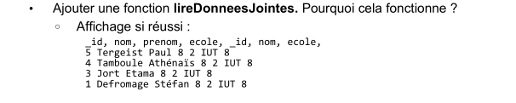

public void lireDonneesJointes() { //faire find avec selection des colonnes, join, et order by
String sql = """
SELECT
p._id AS prof_id,
p.nom AS prof_nom,
p.prenom AS prof_prenom,
p.ecole AS prof_ecole,
e._id AS ecole_id,
e.nom AS ecole_nom,
e.ecole AS ecole_num
FROM mesprofs p
JOIN mesecoles e ON p.ecole = e.ecole
ORDER BY p._id desc;
""";

try (Statement stmt = conn.createStatement()) {
ResultSet rs = stmt.executeQuery(sql);
ResultSetMetaData meta = rs.getMetaData();
int columnCount = meta.getColumnCount();

for (int i = 1; i <= columnCount; i++) {
System.out.print(meta.getColumnName(i));
if (i < columnCount) System.out.print(", ");
}
System.out.println();

while (rs.next()) {
for (int i = 1; i <= columnCount; i++) {
System.out.print(rs.getString(i));
if (i < columnCount) System.out.print(", ");
}
System.out.println();
}

} catch (SQLException e) {
System.out.println("Erreur dans lireDonneesJointes : " + e.getMessage());
}
}

TP4 NoSQL :
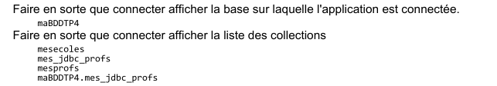

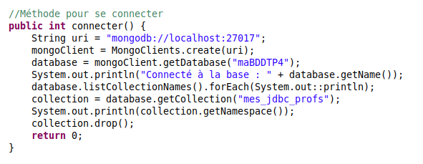
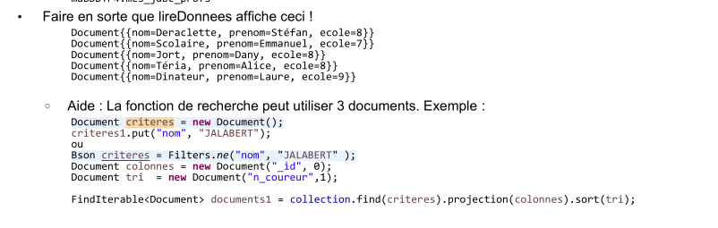
//retenir lire donnees avec filtres
// Méthode de lecture
public void lireDonnees(MongoCollection<Document> collection) {
System.out.println("=== Contenu de la collection ===");
FindIterable<Document> docs = collection.find().projection(new Document("_id", 0));
for (Document d : docs) {
System.out.println(d);
}
}

public void lireDonneesAjuster(MongoCollection<Document> collection) {
System.out.println("=== Contenu de la collection filtre ===");
Bson filtre = Filters.eq("nom", "Jort"); //filtre contenant jort
Bson filtre2 = Filters.ne("nom", "Jort"); //filtre ne contenant pas jort
Document tri = new Document("prenom",-1); //1 pour l'ordre croissant et -1 pour décroissant
Document affichage = new Document("_id", 0); //Ici sa enleve l'id, possible de mettre ce qu'on veut comme mongosh
FindIterable<Document> docs = collection.find(filtre2).projection(affichage).sort(tri);
for (Document d : docs) {
System.out.println(d);
}
}

